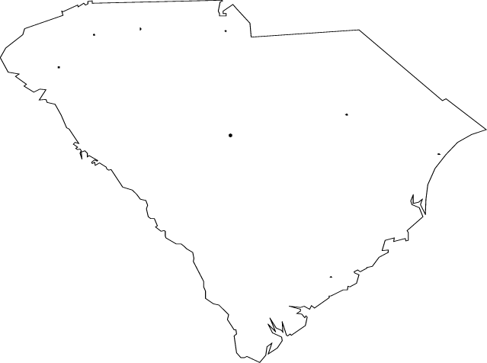
Phone (843) 813-7569
Professional Disc Jockey Services
P.O. Box 99, Summerville, SC 29484, Fax (866) 480-1514
Email:info@carolinamobilemusic.com
Web: www.carolinamobilemusic.com

Event Planner/Questionnaire

It has been our experience that the more information you can provide us in advance, the better we can serve you. When convenient, please complete the following and return it to us at least two weeks in advance of the event date. If you should have any questions or wish to discuss any aspect of your event, please do not hesitate to call.

Client Name: Phone:

Event Date: Start Time: End Time:

Type of Event:

Location: Contact Person:

Expected number of guests: Are the majority from out of town?

Age range of guests: from to with majority being from to years old.

Caterer: Contact Person:

Name of client’s representative at event:

Location for the DJ setup:
(Please have the caterer provide one table approximately six feet long with a tablecloth and a skirt that matches the decor of the event).

Attire for the DJ:

DJ Personality:

(Unless you specifically request otherwise, the DJ will assume that you and your guests will prefer to hear music rather than the DJ, and the DJ will take the microphone only to make necessary announcements. The DJ will always be aware that this is YOUR event, and not theirs, and will at all times strive to please you and your guests.)

MEAL

Will there be a meal? Type?

Will there be a blessing before the meal?

If so, who will give it?

Should the person giving the blessing be introduced?

Should the DJ announce the meal? If so, how?

(For example, the DJ can invite your guests to “feel free to follow the guest of honor to the buffet,” or say “ladies and gentlemen, please find your seats, the meal will be served shortly.”

BACKGROUND MUSIC

What style of background music would you like played during the meal? (Use the “x” key on your computer).

Beach Music
Classical
Love Songs
Smooth Jazz Vocals
Smooth Jazz Instrumentals
Soft Instrumental Music
Other:

EVENT MUSIC

Please select one or more music styles to be played for the main portion of the event: (Use the “x” key on your computer).

Beach & Shag / Big Band / Classic Rock & Roll / Club Dance / Country / Disco / Hip Hop / Jazz / Latin / Oldies / Rap / Reggae / Modern Rock / Slow Dances / Top 40 / Other:

Please indicate styles of music NOT to be played even if requested:

FORBIDDEN SONGS

Please list any songs that you do not want to be played under any circumstances:

ALLOWED SONGS

Please list any songs that are to be played ONLY if REQUESTED by a guest:

REQUESTED SONGS

Please list any specific songs that you would like to be played at some time during the reception:
Title / Artist | Notes (specific time to play, person to dedicate to, etc.)

(Preferences in music are as varied as they are for food. Please keep in mind that while some of your favorite songs may have special meaning to you, they may not be easily danceable and may not be favorites of your guests. While we will certainly accommodate your requests, you may wish to use care to not “over-program” your event. You may wish to “leave some room” for your DJ to “read the crowd” and to take requests from your guests).

EXPLICIT LYRICS

Some songs contain suggestive or explicit lyrics that may be offensive to some persons. Please indicate your preference regarding songs containing such lyrics or containing profanity:

GUEST REQUESTS

Should the DJ take requests from your guests?

If so, please indicate your preference for handling such requests:

Should the DJ invite requests from your guests?

COMMENTS:
(Please add any additional comments that you feel may be helpful to your DJ in understanding the requirements of your event).

